ORIENTATION SPEECH ACADEMIC YEAR 2019/2020

DEPARTMENT OF INFORMATION AND COMMUNICATION TECHNOLOGIES (ICT)

A WELCOME MESSAGE FROM THE HEAD OF DEPARTMENT

Dear Students, it is my great pleasure to welcome you to the Department of Information and Communication Technology (ICT) in the Faculty of Science Technology and Environmental Studies (FSTES) of The Open University of Tanzania (OUT). I wish to congratulate each of you, first on having secured your place and for having the good sense to choose to study in this University.

I welcome you to our Department and ensure that we will do everything possible to equip you with the best possible teaching resources, practical exposure and training methods so that you are able to shape up your life and career for a challenging world out there.

ABOUT THE DEPARTMENT
The Department of ICT is one of the five departments in the Faculty of Science Technology and Environmental studies (FSTES) of the Open University of Tanzania (OUT). The Department educates, train and support students in their ICT endeavors to gain competitive and practical based digital skills and knowledge. The Department offers the following programmes: Master of Science in Computer Science (MSCS) and Master of Science in Information Technology Management (MSITM), Bachelor of Science Information and Communication Technology (B.Sc. ICT), Bachelor of Science in Data Management (B.Sc. Data Management), postgraduate programmes (PhD and MSc programmes in ICT), and non-degrees programmes (Certificate in Computing and IT (NTA Level 4) and Diploma in Computer Science (NTA Levels 5 and 6).
For further details on the programmes and how to join us please read the University prospectus and/or visit us at the Open University of Tanzania HQ in Dar es Salaam or any of our regional centers.

NON-DEGREE PROGRAMMES
- Basic Certificate in Computing and IT - NTA Level 4

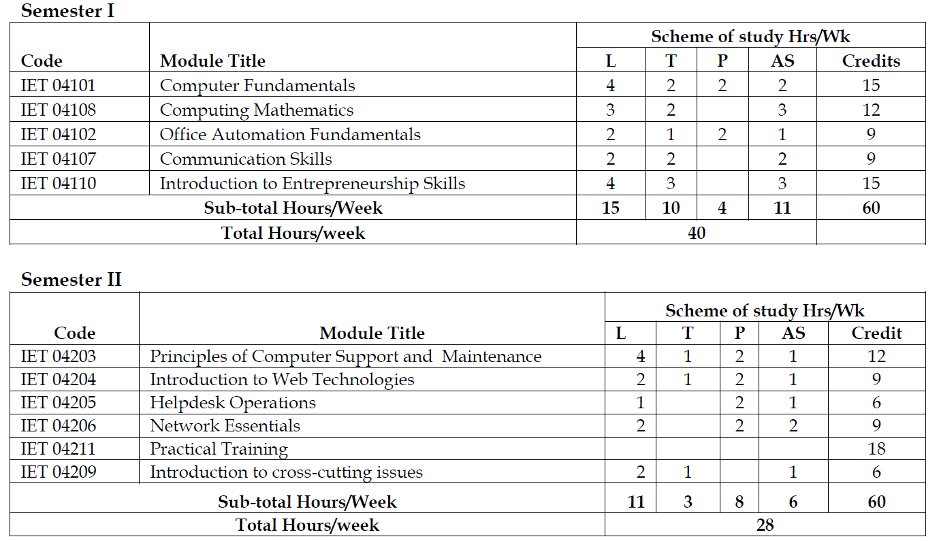

- Technician Certificate in Computing and IT - NTA Level 5

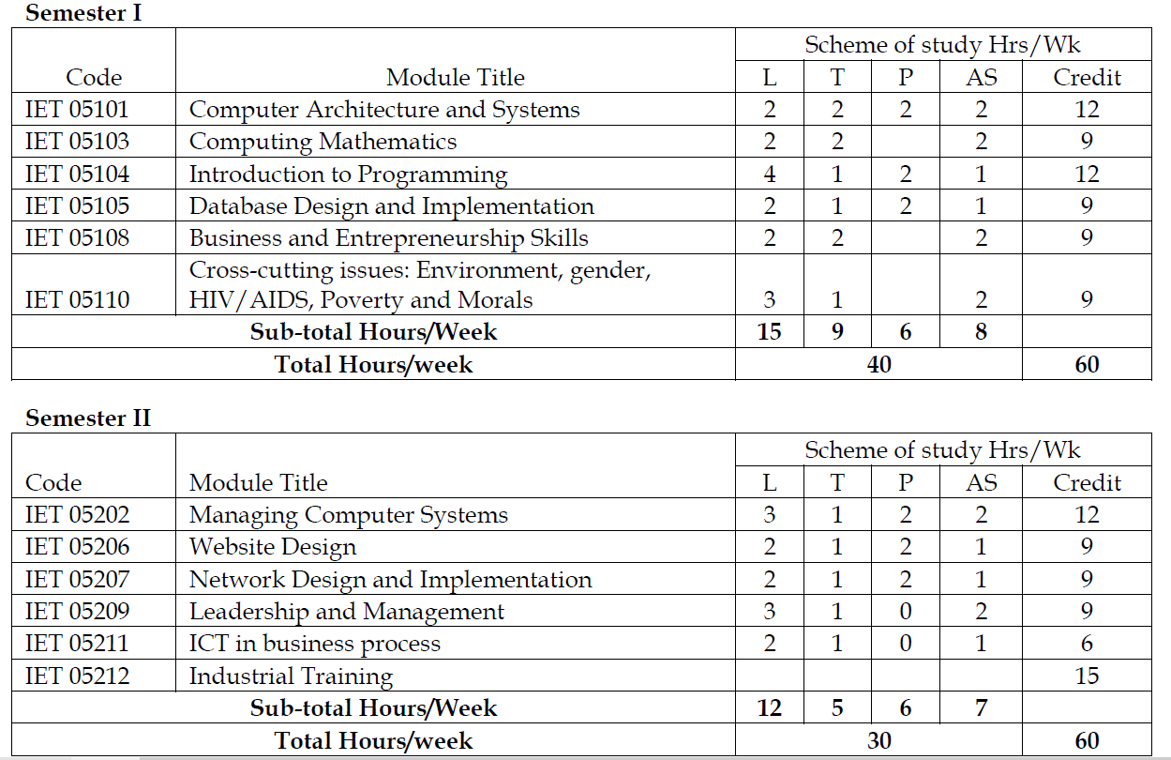

- Ordinary Diploma in Computer Science - NTA level 6

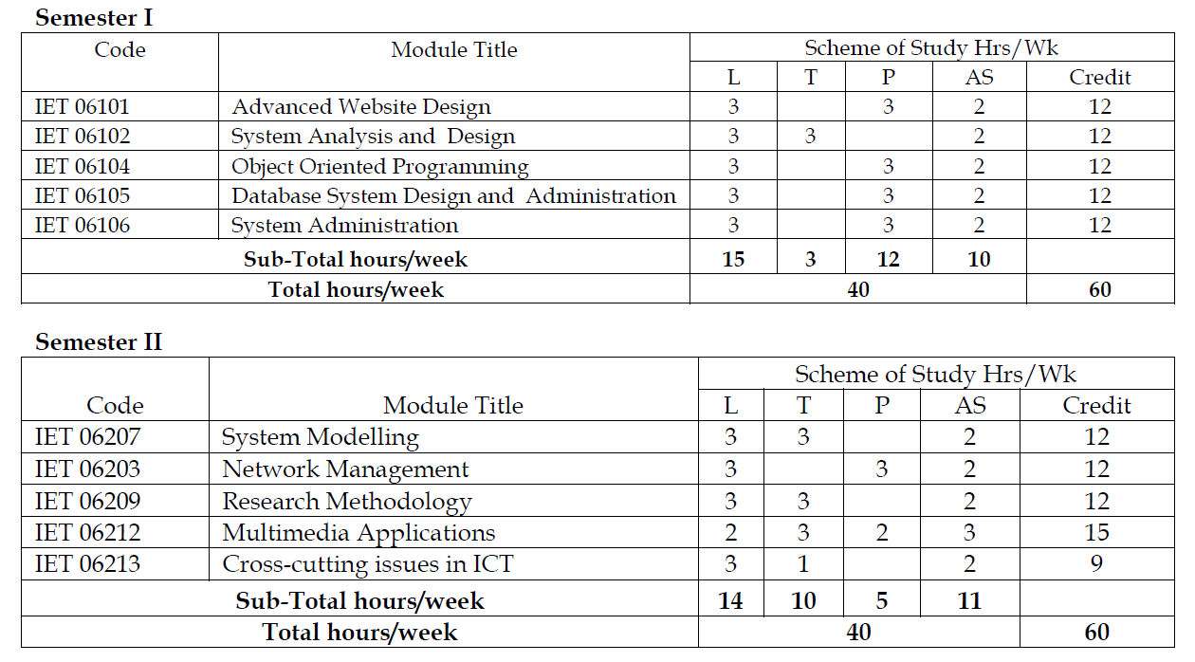

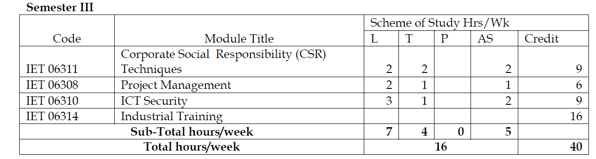

UNDERGRADUATE DEGREE PROGRAMMES

Bachelor of Science Information and Communication Technologies
The award of the degree will require students to pass and complete all the prescribed core courses adding up to 40 units. A student can opt any of the elective courses.
This programme is offered in blended mode (online learning and face to face sessions). All students must attend face to face sessions in scheduled timetable planned by the Department. To receive information on the timetable ensure that you send your email to the coordinator and Head of Department include your name, programme, year of study, registration number and center.

Level One
Course Code | Course Name | Mode of Delivery |  | Number of Units
Course Code | Course Name | Equivalent Lecture hours | Equivalent Practical hours | Number of Units
OIT 111 | Fundamentals of Information Systems | 18 | 35 | 1
OIT 112 | Computer Mathematics I | 35 | - | 1
OIT 113 | Probability and Statistics | 35 | - | 1
OIT 114 | Communication Skills for IT | 35 | - | 1
OIT 115 | Introduction to Computer Architecture | 35 | 70 | 2
OIT 116 | Programming in C | 35 | 70 | 2
OIT 117 | Data Communications and Networking I | 18 | 35 | 1
OIT 118 | Industrial Training I
OIT 119 | Web Design and Development | 35 | 70 | 2
 | Total | 246 | 280 | 11

Level Two
Course Code | Course Name | Mode of Delivery |  | Number of Units
Course Code | Course Name | Lecture hours | Practical hours | Number of Units
OIT 211 | Operating Systems | 35 | 70 | 2
OIT 212 | Software Design and Development | 35 | 70 | 2
OIT 213 | Computer mathematics II | 35 | - | 1
OIT 214 | Object Oriented Programming with Java | 35 | 70 | 2
OIT 215 | Data Communication and Networking II | 35 | 70 | 2
OIT 216 | Introduction to Computer Security | 18 | 35 | 1
OIT 217 | Database Concepts and Design | 18 | 35 | 1
OIT 218 | Web Programming | 35 | 70 | 2
OIT 219 | Industrial Training II |  | 120
 | Total | 246 | 540 | 13

Level Three
Course Code | Course Name | Mode of Delivery |  | Number of Units
Course Code | Course Name | Equivalent Lecture hours | Practical hours | Number of Units
OIT 311 | Information Systems Security Management | 18 | 35 | 1
OIT 312 | Information Systems Planning and Management | 18 | 35 | 1
OIT 313 | Network Design and Administration | 18 | 35 | 2
OIT 314 | Computer Ethics and Social Cultural Implication | 35 | - | 1
OIT 315 | Wireless Networks | 35 | 70 | 2
OIT 316 | Final Year Project |  | 180 | 3
OIT 317 | Database Implementation and Administration | 18 | 35 | 2
 | Total | 124 | 355 | 12

Elective courses
Course Code | Course Name | Mode of Delivery |  | Number of Units
Course Code | Course Name | Equivalent Lecture hours | Equivalent Practical hours | Number of Units
OIT 220 | Introduction to e-Business | 30 | 30 | 1
OIT 221 | Multimedia Technologies and Applications | 30 | 30 | 2
OIT 318 | Introduction to Computer Graphics | 30 | 60 | 2
OIT 319 | Programming in C++ | 30 | 60 | 2
 | Total | 120 | 180 | 7

Bachelor of Science in Data Management (B.Sc. in Data Management)
The award of the degree will require students to pass and complete all the prescribed core courses adding up to 40 units. A student can opt any of the elective courses.
This programme is offered in blended mode (online learning and face to face sessions). All students must attend face to face sessions in scheduled timetable planned by the Department. To receive information on the timetable ensure that you send your email to the coordinator and Head of Department include your name, programme, year of study, registration number and center.

Level of study | Course code | No of credits
Level 1
- Fundamentals of Information Systems | OIT 131 | 10
- Discreet Mathematics with Applications | OIT 132 | 10
- Probability and Statistics | OIT 133 | 10
- Communication Skills for IT | OIT 134 | 10
- Data Structures and Algorithm | ODM 108 | 20
- Introduction to Computer Programming Languages | ODM 103 | 10
- Data Governance in Organizations | ODM 105 | 10
- Database Design and Implementation | OIT 138 | 20
- Operating Systems | OIT 231 | 10
- Industrial Training 1 | OIT 139 | 20
Level 2
- Graphics Processing & Human Computer Interaction | ODM 201 | 10
- Enterprise Resource Planning (ERP) Systems | ODM 204 | 20
- Research Methods & Data Analysis | ODM 206 | 20
- Fundamentals of GIS | ODM 207 | 10
- Cross cutting issues | ODM 209 | 10
- E-Commerce and Entrepreneurship | ODM 211 | 10
- Data Mining Techniques and Application | ODM 212 | 20
- Data Communications and Networking | OIT 137 | 10
- Inventory Models and Queuing Theory | OIT 233 | 10
- Industrial Training II | OIT 238 | 20
Level 3
- Multimedia Technologies | ODM 301 | 10
- Data Security | ODM 308 | 20
- Computer Ethics and Social Cultural Implication | OIT 333 | 10
- Final Year Project | OIT 334 | 30
Elective Courses
- Education Data Management and Digital Libraries | ODM 304 | 20
- Health Data Management | ODM 305 | 20
- Data in Agriculture Systems | ODM 306 | 20
- Financial Data Management | ODM 307 | 20
- Environment Data Management | ODM 309 | 20
Total |  | 440

POSTGRADUATE PROGRAMMES
MSITM
The Master of Science in Information Technology Management is a mixed mode programme and consists of taught courses and a dissertation. The programme consists of a total of 18 units.. Candidates must complete and pass 6 core courses with a total of 12 Units and a Dissertation with 6 units. The dissertation is compulsory to all candidates.
 | CORE COURSES
CODE | COURSE TITLE | Units
OCS 601 | Scientific Research Methods | 1
OIM 601 | IT Entrepreneurship and Management | 1
OIM 602 | IT Security Planning and Management | 2
OIM 603 | IT Strategic Management, Communications and Leadership | 2
OIM 604 | Legal and Ethical Aspects of Computing | 2
OCS 607 | Management Information Systems | 2
OCS 610 | Project | 6
 | ELECTIVE COURSES (Choose 1)
CODE | COURSE TITLE | Units
OIM 605 | Networks and Smart Computing | 2
OIM 606 | Data and Knowledge Management | 2

MSCS
The Master of Science in Computer Science is a mixed mode programme and consists of taught courses and a dissertation. The programme consists of a total of 18 Units. Candidates must complete and pass 6 core courses with a total of 12 Units and a Dissertation with 6 units. The dissertation is compulsory to all candidates.
There are two streams leading to MSc in Computer Science which are Information Systems and Cyber Security (the different streams will only be reflected on Transcripts, but the Certificate will read MSc in Computer Science). Both streams will share 5 core courses. However, specialized courses will be selected based on the stream. Furthermore, the candidate must produce a project that is in line with the chosen stream.
 | CORE COURSES
CODE | COURSE TITLE | Units
OCS 601 | Scientific Research Methods | 1
OIM 601 | IT Entrepreneurship and Management | 1
OCS 602 | Data Warehouse and Data Mining | 1
OCS 603 | Core networks, Virtualization and Cloud Computing | 2
OCS 604 | Advanced Programming and Algorithms | 1
OCS 609 | Dissertation | 6
SPECIALIZATION COURSES
INFORMATION SYSTEMS
CODE | COURSE TITLE | Units
OCS 605 | Mobile and Web based Information Systems | 2
OCS 606 | Intelligent Expert Systems | 2
OCS 607 | Management information systems | 2
SPECIALIZATION COURSES
CYBER SECURITY
CODE | COURSE TITLE | Units
OCS 608 | Ethical Hacking, Security Audit and Digital Forensics | 20
OCS 609 | Network Security and Cryptography | 20
OIM 602 | IT Security Planning and Management | 20

Head of the Department of ICT

Dr. Catherine Mkude: Tel.: 0719868376, E-mail: catherine.mkude@out.ac.tz

Coordinators
Postgraduate programmes
Grace Mbwete: 0655315978, grace.mbwete@out.ac.tz
Undergraduate degree and Non-degree programmes
Mr. M Ndibalema, mwemezi.ndibalema@out.ac.tz

Present Tutors in the Department Of ICT
Prof. G Oreku: george.oreku@out.ac.tz
Dr R Bhalalusesa, rogers.balalusesa@out.ac.tz
Dr. E Nfuka, edephonce.nfuka@out.ac.tz
Dr. S Ally, said.ally@out.ac.tz
Dr. K Kalegele khamisi.kalegele@out.ac.tz
Mr. M Ombeni, mathias.ombeni@out.ac.tz
Mr. E Lukwaro, elia.ahidi@out.ac.tz
Mr. G Haonga, godfrey.haonga@out.ac.tz
Mrs E Isaya, elizabeth.isaya@out.ac.tz
Mr. R Ambele, raiton.ambele@out.ac.tz

The Head of Department
Faculty of Science Technology and Environmental Studies
P. O. Box 23409
Dar es Salaam

